**Week 1 Assignment**

**Step 1: Open Power BI and click on Blank Report.**

**Step 2: Import the CSV file (Dataset).**

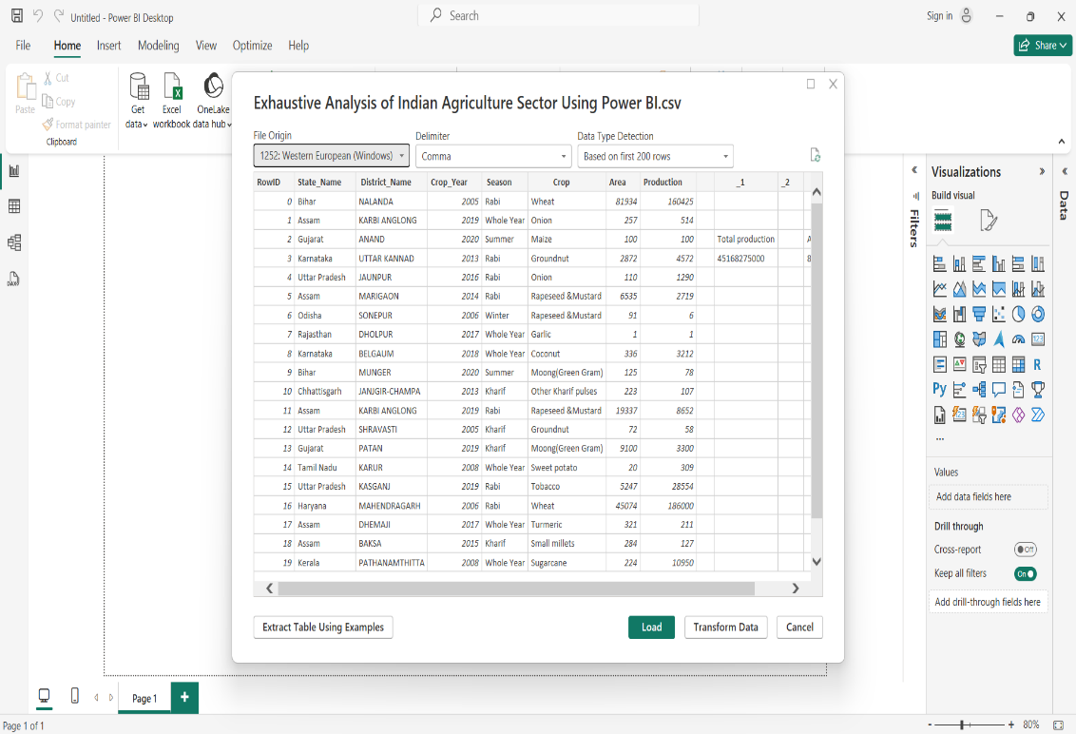

**Step 3: #Click on Load when data is cleaned.**

**#Click on Transform to process data.**

**Step 4: #Report View: For Visualization of data.**

**#Table View: For Overview of data.**

**#Model View: Create Relation among data.**

**Step 5: Click on Transform Data to open Power Query Editor.**

**Step 6: Remove unwanted columns, right click on column and click remove.**

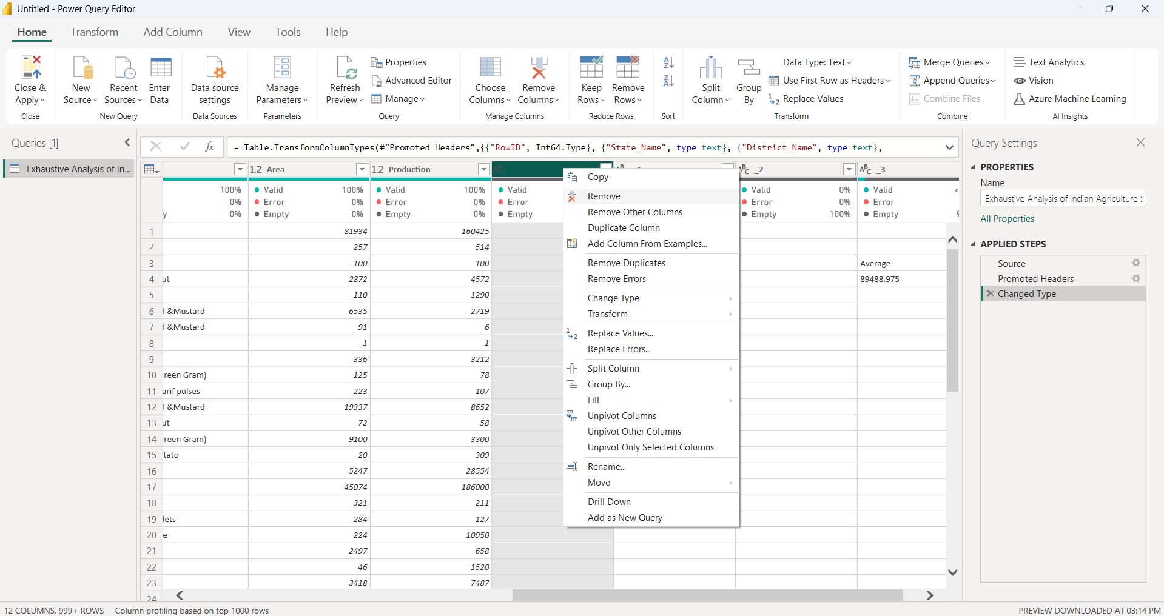

**Step 7: To check if data contains null values or Error, Click on View and then Column Quality.**

**#Error: Invalid Data Type.**

**#Empty: Null or No Value.**

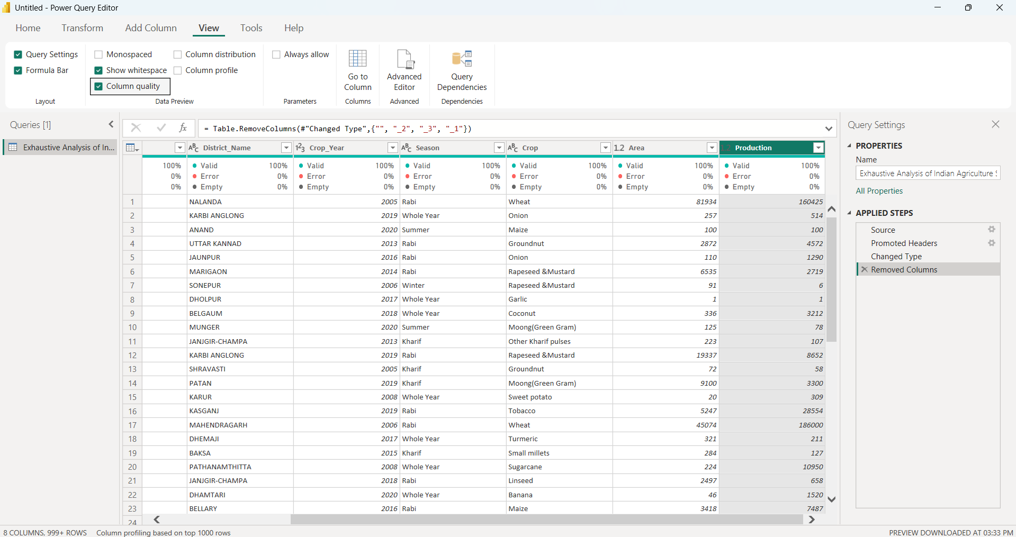

**Step 8: Close and apply.**

**Step 9: Click Table View to view resulting table.**

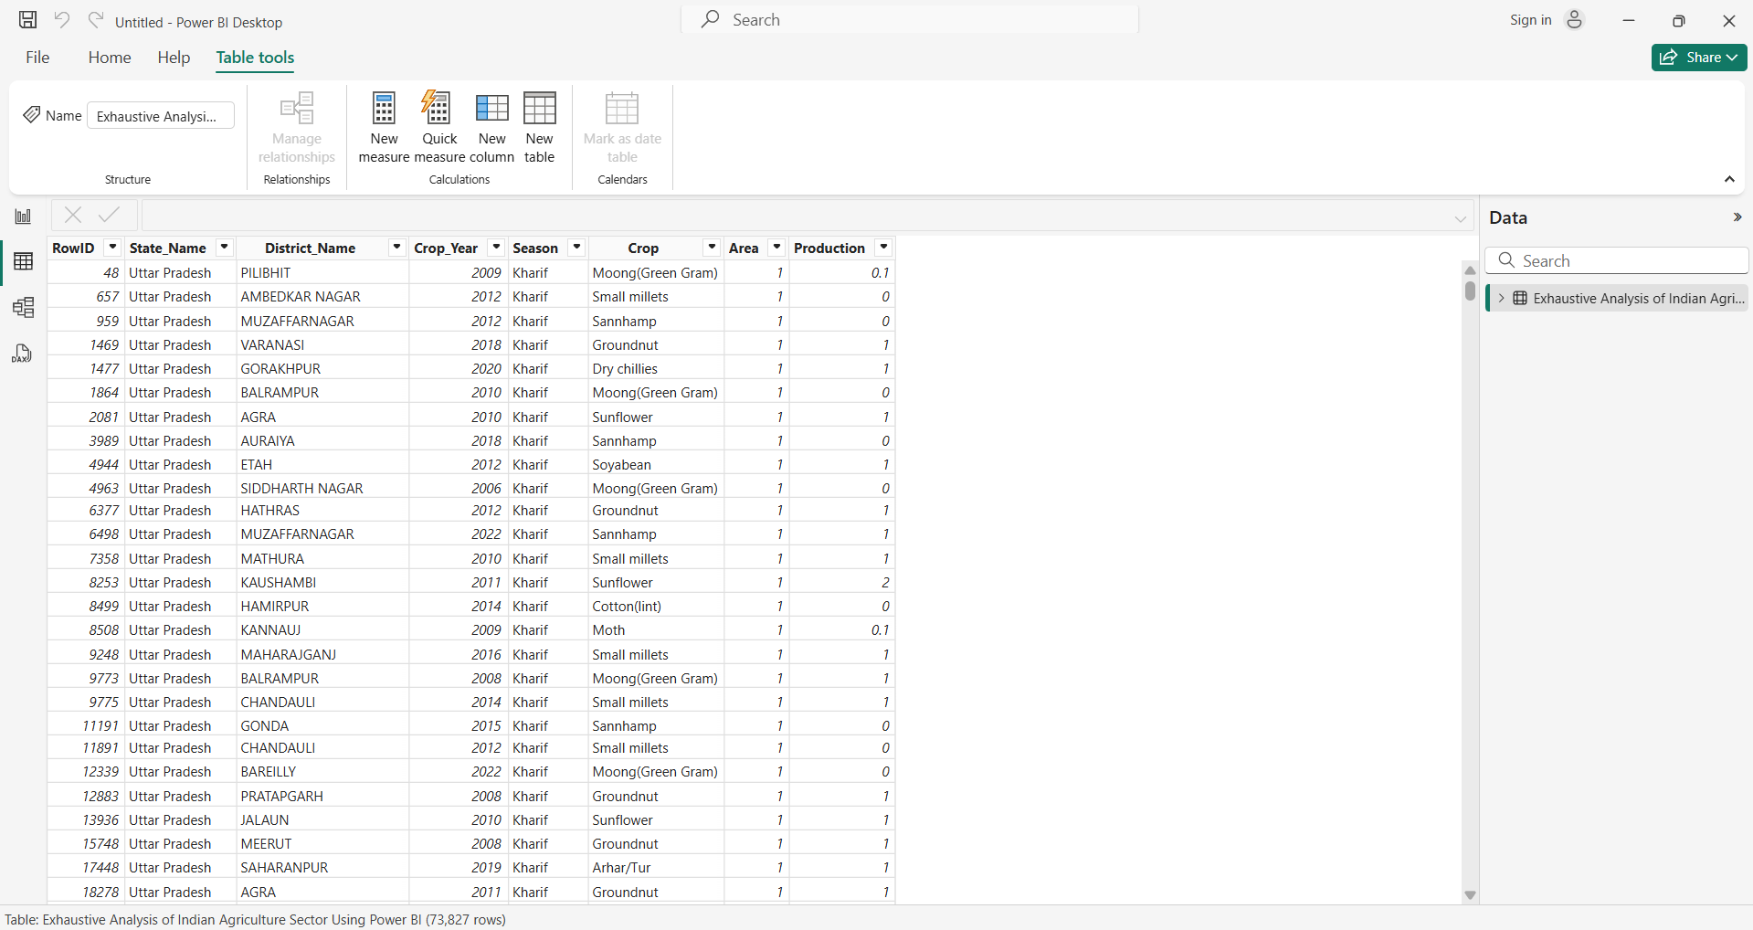

**Step 10:** **Save the File.**